# Customer Meeting

Customer meeting date to demo this iteration.

Our next meeting with client is on 29-March-2022 at 4:45 pm

### Meeting notes from the previous client meeting:

* Gave the demo for iteration1 implementation
* Got approval from the client
* Discussed on improvements and add-on features in analysis display screen. But decided not to include them in MVP of the product
* Decided to implement host side event creation implementation for iteration2

## User Stories Implemented

User stories implemented in this iteration.

User stories we implemented in this iteration are:

1. User Story: As a host, I want to create a event
2. User Story: As a host, I want to add and customize questions in events
3. User Story: As a host, I want to add points to the answer options.
4. User story: As a host, I want to see a list of all events I have created.

We have implemented all the user stories we planned to implement for this iteration.

# Tasks Accomplished.

Tasks accomplished in iteration2:

1. Meeting with client and demo iteration1 changes
2. Create models as per the DB model diagram at <https://lucid.app/lucidchart/901b0e43-df07-48df-bdc9-1ae8d9c21f7c/edit?invitationId=inv_9b5c53ff-65f9-4977-80c7-e0b6e4731c41&page=J960fNmy6zCK#>
3. Developed API for adding events for hosts
4. Developed API for adding questions for hosts
5. Developed API for reading events created by hosts
6. Developed API for getting list of questions and answer options for a given event id
7. Developed BDDs and TDDs for the above 4 apis
8. Developed frontend UI for creating events
9. Developed frontend UI for viewing events
10. Developed frontend for creating questions and answer options
11. Developed frontend for viewing list of questions and answer options
12. Developed BDDs and TDDs for frontend

# TESTS

## Backend

**Results:** BDDs test results for backend apis

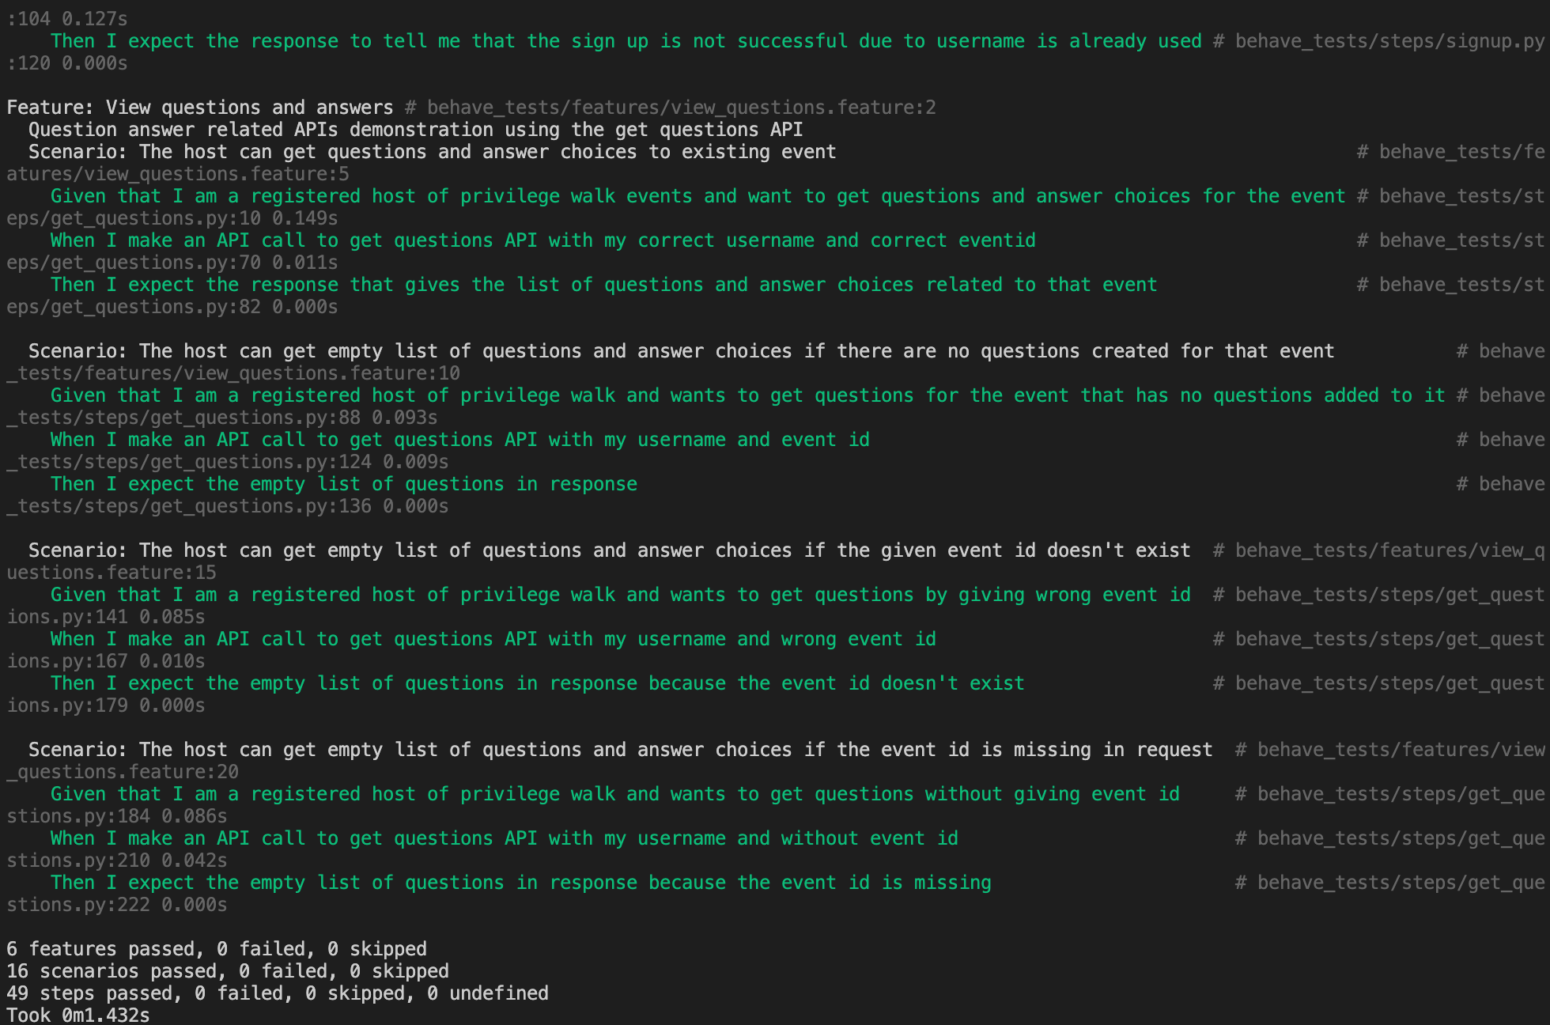

Backend TDDs

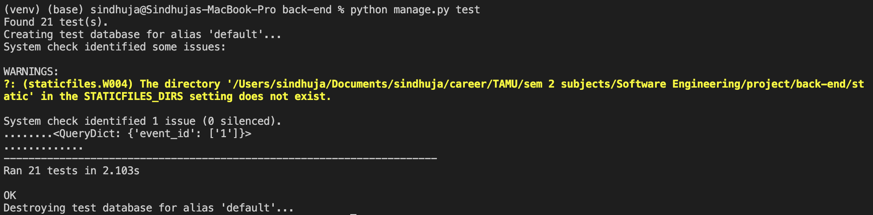

**Coverage:** Backend tests with 97% coverage.

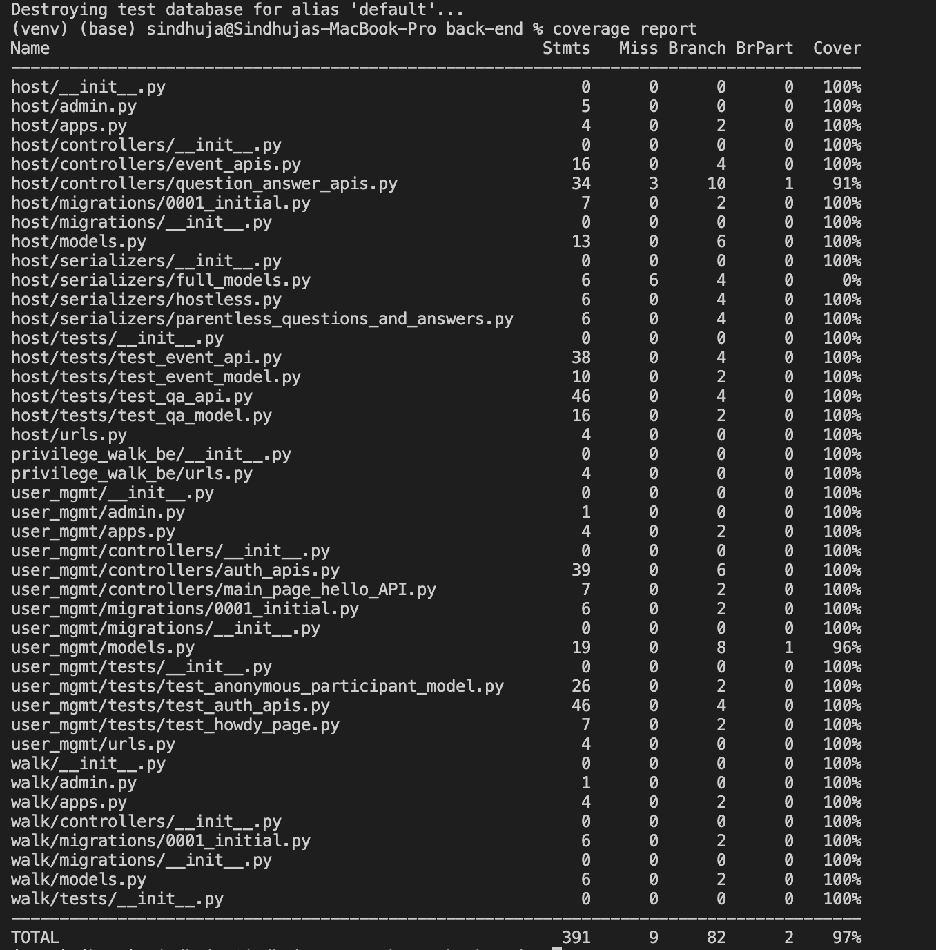

The instructions to get coverage report is mentioned in ReadMe of repo: <https://github.com/Privilege-walk/back-end.git>

Steps to Run backend tests:

1. Git clone the backend repo
   1. git clone https://github.com/Privilege-walk/back-end.git
2. Install requirements
   1. Look at the Running instructions mentioned in ReadMe at <https://github.com/Privilege-walk/back-end.git>
   2. Once you create and activate virtualenv install the requirements using command
      1. pip3 install -r requirements.txt
3. Run BDDs
   1. We used ‘behave’ to create BDDs for the features and scenarios as we are developing backend in Django
   2. The BDDs can be run at once by using below command:
      1. python manage.py behave
4. Run TDDs
   1. All the TDDs for all apis scenarios can be tested using the command
      1. python manage.py test

For more detailed explanation on instructions to run tests for backend are mentioned in ReadMe of the repo: <https://github.com/Privilege-walk/back-end.git>

## FRONTEND

**TDDs:**

**Coverage**: TDDs frontend test coverage

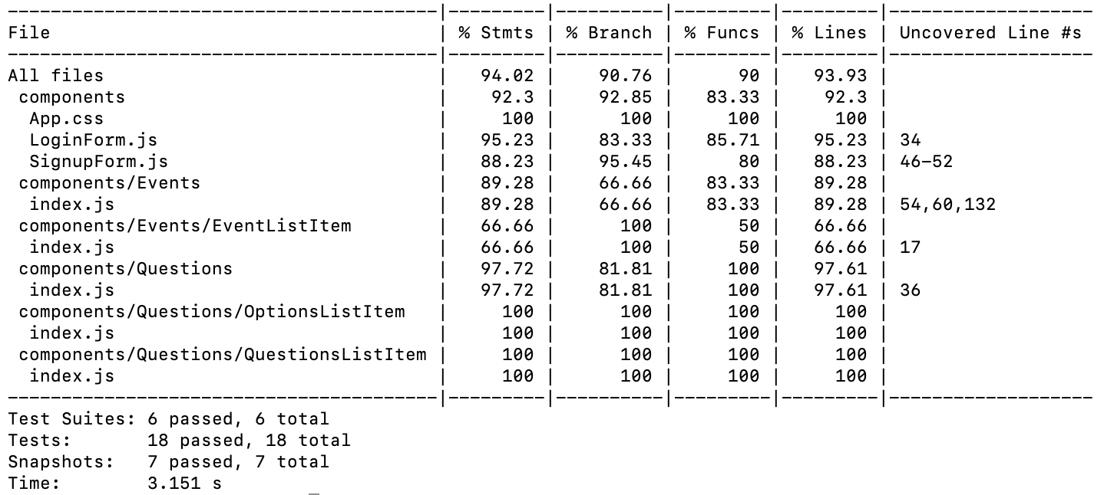

**Results:** for TDDs

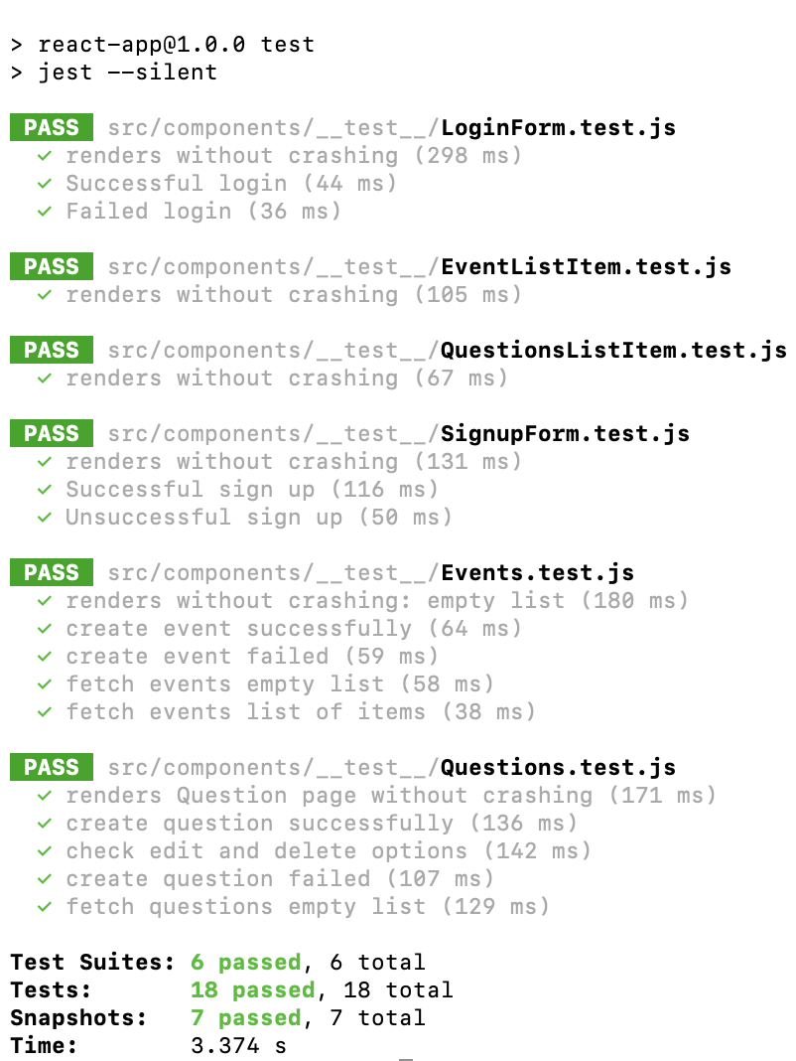

**BDDs**

**Results:**

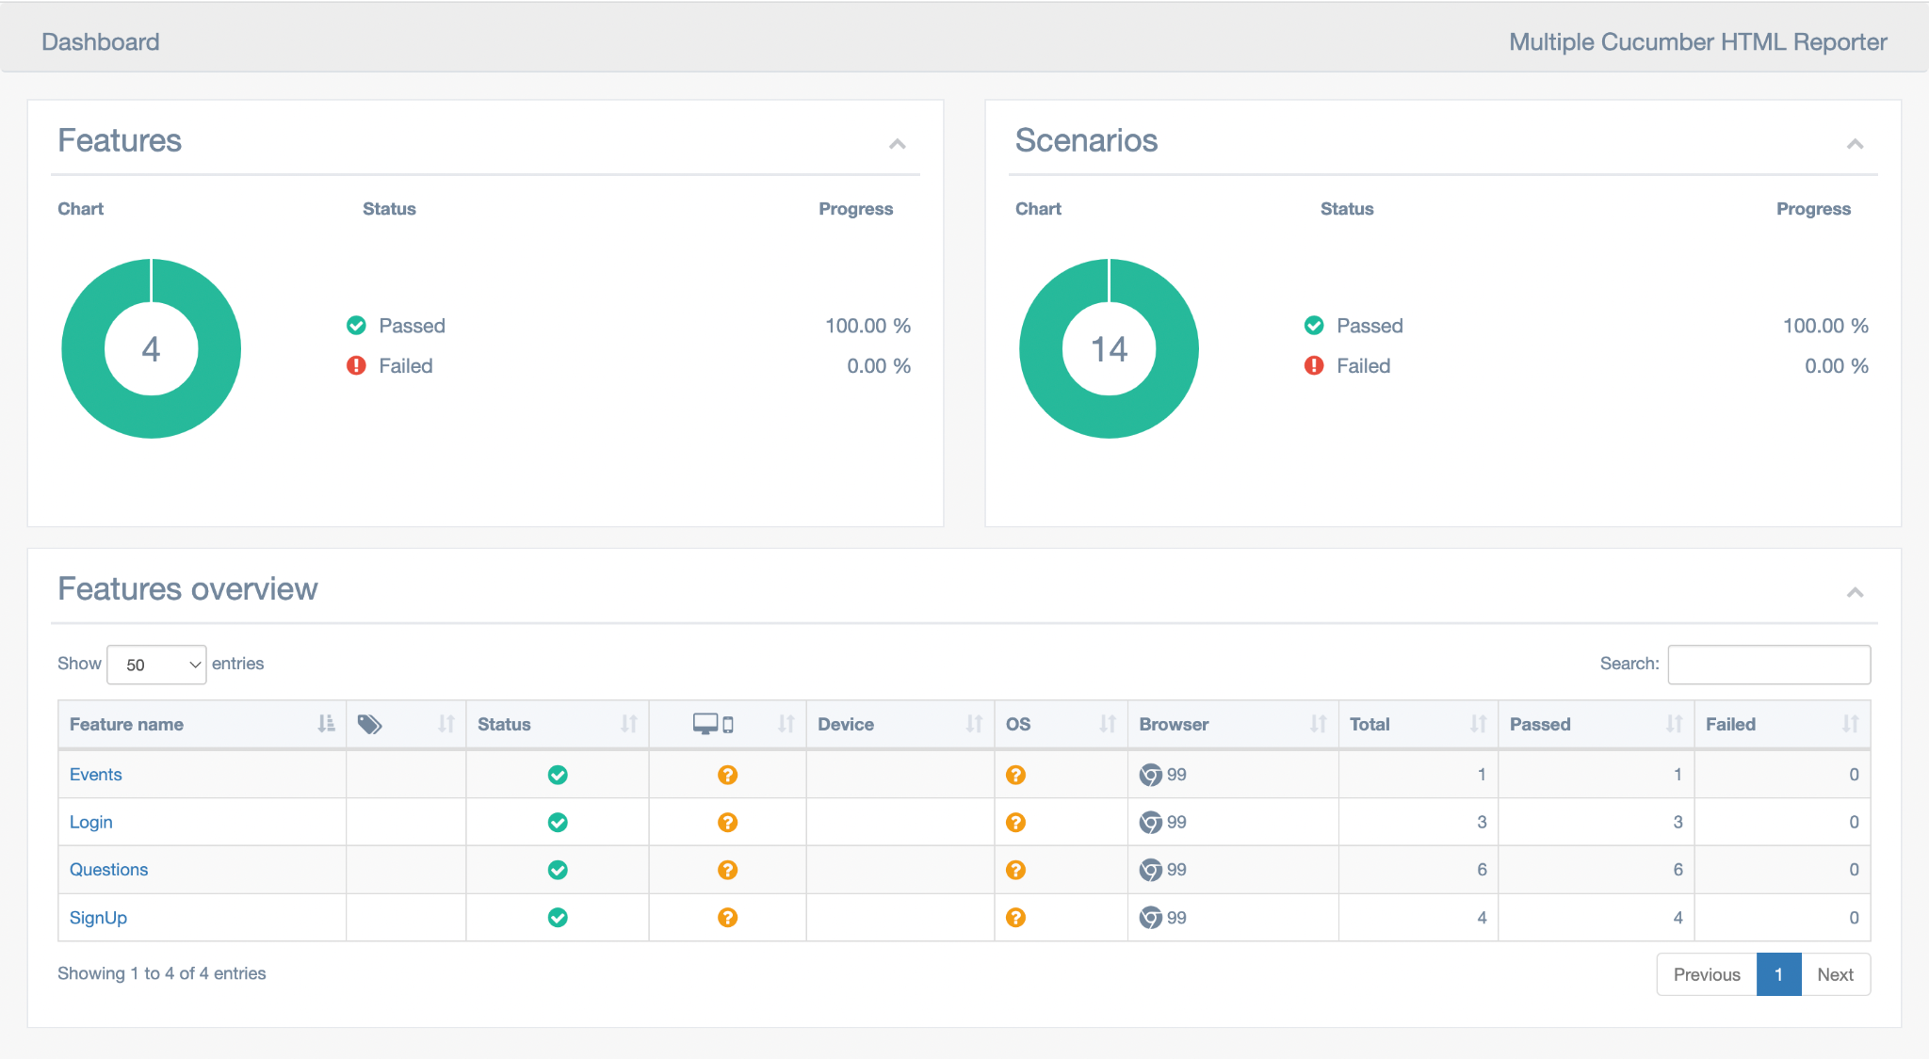

**STEPS**

Steps to Run frontend tests:

1. Clone the repository and switch to the root of the repository.
   1. git clone <https://github.com/Privilege-walk/front-end.git>
   2. cd front-end
2. Install npm packages.
   1. npm install
3. RUN TDDs.
   1. npm run test
4. RUN BDDs
   1. Make sure frontend is up by running.
      1. npm start
   2. Make sure the back-end is running by (I’m assuming you’ve cloned the backend repository and installed requirements. See steps 1 and 2 below in “Steps to Run backend tests”):
      1. python manage.py runserver
   3. Run BDD tests by running.
      1. npm run test-bdd

For more detailed steps please checkout README for frontend: https://github.com/Privilege-walk/front-end/blob/main/README.md

# LINKS

Pivotal Tracker: <https://www.pivotaltracker.com/n/projects/2556087>

GitHub Repo Backend: <https://github.com/Privilege-walk/back-end>

GitHub Repo Frontend: <https://github.com/Privilege-walk/front-end>  
GitHub Repo Project: <https://github.com/Privilege-walk/privilege-walk>  
Heroku Deployment backend: <https://privilegewalkbe.herokuapp.com/>  
Heroku Deployment project: <https://privilegewalk.herokuapp.com/>